**Project Design Phase-II**

**ARCHITECTURE**

|  |  |
| --- | --- |
| Date | 19 October 2022 |
| Team ID | PNT2022TMID50978 |
| Project Name | Nutrition Assistant Application |
| Maximum Marks | 4 Marks |

Technical Architecture:

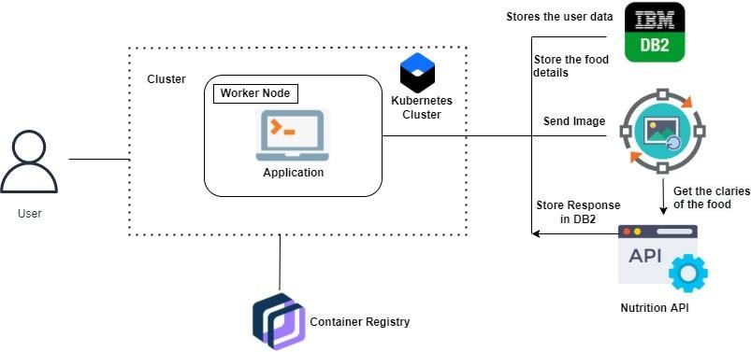

Table-1: Components & Technologies:

|  |  |  |  |
| --- | --- | --- | --- |
| **S.no** | **Component** | **Description** | **Technology** |
| 1. | User Interface | User interacts with application | HTML, CSS, JavaScript, React JS  etc. |
| 2. | Database | Data Type, Configurations etc. | MySQL, JavaScript, Python,  Python Flask. |
| 3. | Cloud Database | Database Service on Cloud | IBM DB2, IBM Cloud etc. |
| 4. | File Storage | File storage requirements | IBM Block Storage or Other Storage  Service or Local Filesystem |
| 5. | External API-1 | To predict the image that user will upload  in the upload image page | Clarifai's AI-Driven Food Detection  Model. |
| 6 | External API-2 | Food API’s to the nutritional value  for the identified food. | Food API |
| 7 | Infrastructure (Server / Cloud) | Application Deployment on Local System / Local server configuration.  Cloud server Configuration | Local, Cloud Foundry, Kubernetes, Docker… |

Table-2: Application Characteristics:

|  |  |  |  |
| --- | --- | --- | --- |
| **S.no** | **Characteristics** | **Description** | **Technology** |
| 1. | Open-Source Frameworks | Open-source frameworks used. | SendGrid, Python |
| 2. | Security Implementations | Request authentication using encryption. | Encryptions |
| 3. | Scalable Architecture | The scalability of architecture consists of 3 tiers. | Web Server – HTML, CSS, JavaScriptApplication Server – Python Flask Database Server –  IBM Cloud |
| 4. | Availability | Availability is increased by loads balancers incloud VPS. | Working to reduce the severity and likelihood of problems, closely monitoring applications and infrastructure, keeping technical debt in check, automating recovering mechanisms, and regularly putting thoserecovery  mechanisms to the test. |

|  |  |  |  |
| --- | --- | --- | --- |
| 5. | Performance | The application is expected to handle up to 4000predictions per second | Optimize image sizes, use a content delivery network, use website cachingand adopt cloud  based website monitoring |